**PF ASSIGNMENT - 03**

**QUESTION#1**

Write the datatypes of the following values:

* “Introduction to IDE and basic programming constructs”
* 3.14
* 300000000
* 7.0000000000005

ANSWER:

1. String
2. Float
3. Integer
4. Float

**QUESTION#2**

Explain the output of this C program. Why the wrong value is being displayed in the output?

ANSWER:

* Because the format specifier we have used is **%d**, which is only for **integer** values/data.
* We must have to use **%f** for **float** values/data.

**QUESTION#3**

Write a C program that takes two integer values as input from the user. Then swap the values taken from the user and display the output of the variables.

**QUESTION#4**

A customer asks the IT firm to develop a program in C language, which can take tax rate and salary from the user on runtime and then calculate the tax, the user has to pay and the salary he/she will have after paying the tax. Tax rate must be between 0-100.

Source Code: Output:

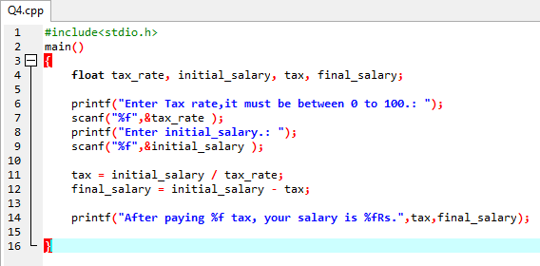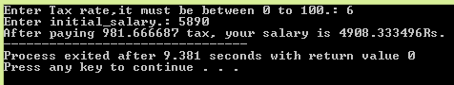

**QUESTION#5**

A car traveled for some hours. The time car traveled is taken at run time of the program, and it must not be negative and must be between one to five hours. The car had not traveled same distance in each hour. The distance that the car covered must not be negative. Write a C Program that computes the Average Speed of the Car in miles per hour. Hint: the restrictions can be displayed in the form of message on the window.

**QUESTION#6**

A person travels 10 kilometers in south from his home to go to the university in car then he travels 10 kilometers in west then he travels another 5 kilometers south and finally he travels 15 kilometers in north with the fuel consumption of 3 liters/km. Calculate how far away is his university from home and how much fuel he consumes daily in this two way trip?

Output:

**QUESTION#7**

Construct a C program with the flowchart below. The input value of the Principle must be between 100 Rs. To 1,000,000 Rs. The Rate of interest must be between 5% to 10% and Time Period must be between 1 to 10 years.

Hint: these restrictions can be displayed in the form of message on the window. Simple interest can be computed by using the formula mentioned below. Simple Interest=(P*R*T)/100

Source Code: Output:

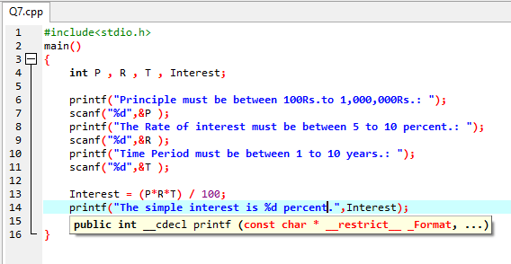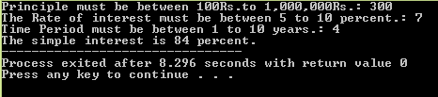

**QUESTION#8**

Calculate the area for a rectangle in which user inputs width and length of a rectangle. Formula: area of a rectangle=width * height.

Source Code: Output: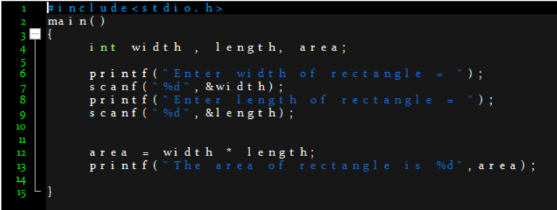

**QUESTION#9**

Write a C program to print the following shapes using escape sequences. Moreover, you are required to compile and execute these programs using CMD.



Source Code: Output:

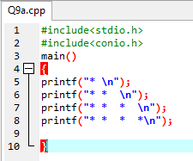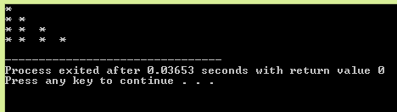

b)

Source Code: Output:

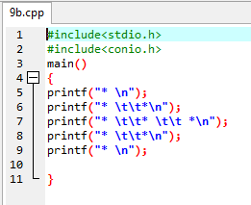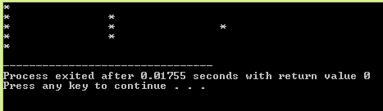

**QUESTION#10**

For 4 months, Ali starts a diet plan to lose his weight. In the first month, he loses 5kg. In the second month he loses another 10kg, In the third moth he loses another 12kg and finally in the last month he loses 7kg. calculate how much weight he has lost per month, on average? Also calculate his weight right now if his initial weight was 110kg?

Output:

